Contents

Introduction 1

Functional Requirements 1

Non-Functional Requirements 2

Questions 2

Screen Mocks 3

Login Screen 3

Home Screen 4

Create New Violation 5

# Introduction

Accessibility Control Platform (ACP) will be a social platform of which users will share accessibility problems in their neighborhood. These shares will be measured and graded by the community.

After grading, the community will be able to access various reports of different viewpoints on these shares. If any authorized organization which is responsible for the region of the shared accessibility problem is registered then they will be informed.

# Functional Requirements

1. Any user that shall use the system should register using a unique email, user name and strong password. Email shall be used in login operations along with the password.
   1. ‘Forgot my password’ functionality shall be provided. User shall enter email address and if any user record matches that information then a new password will be send to the found user’s email address.
2. Any user may identify itself as an authorized user (municipality or any responsible government organization) by selecting an option while registering.
   1. Any authorized user should select a region (city, town or district) of responsibility. Any violation related to that region shall be also informed to that user.
3. Any share of accessibility problem shall include a photo of the issue, description, geolocation (mobile users) or address (desktop users), timestamp info and username of the user. If the user has any means to measure the area of problem, he/she can provide the type of violation and measurement results.
   1. Types of Violation shall be: Pavement ramp, architectural obstacles, parking lot, bus stop, street furniture, access to buildings, indoor factors.
   2. For every types of violations, there shall be sub types, such as slope violation, width violation, surface coating violation, absence of level ground at the end of ramps, short ramps etc.
   3. For any violation that are not categorized yet should be entered as “Other”.
4. Degree of violation shall be represented as LOW, MEDIUM and HIGH. These levels shall be clearly identified for every types of violation so that application/community shall decide the level of violation by simply evaluating the measurements. For example; for pavement ramp violations, one of the expected measurement entry is the slope of the ramp (if any ramp exists). 1/12 (>8%) is the maximum allowed value. If the slope is more than 12% then it is considered dangerous. Therefor we can assume 9% is the LOW, 11% is the MEDIUM and 12% is the HIGH degree of violation for this type of accessibility problems.
   1. If a violation type is “Other”, that is uncategorized, then the community will decide the degree.
5. The community of the application can decide/change the degree of a violation shared by any user. Every user has the right to cast a vote for the violation degree of a violation. A user can cast a vote for any violation only once. A user can cast vote for any number of violations.
   1. A violation should be voted by at least 10 users to be valid, otherwise it will be considered as “not yet graded”.
   2. Average of the votes shall be used to calculate the final score.
6. A status shall be assigned to every violation. Initial value shall be “OPEN”. When the violation resolved then status shall be updated to “RESOLVED”.
   1. To enable the ‘Resolved Button’ a new photo must be uploaded showing the new status of the area. After the upload ‘Resolved Button’ can be clicked by the user.
   2. The resolution should be confirmed by at least 10 other users to be considered as “RESOLVED” by the system. Otherwise the status of the violation shall remain at “RESOLUTION CONFIRMATION EXPECTED”.
7. The community of the application shall comment on the violations entered by any user including the original poster of the violation.
8. Home page of the application will display a dashboard showing ‘5 most dangerous violations’, ‘Last 5 violations’, ‘Last 5 resolved violations’, ’5 most dangerous regions for handicap’, ’5 most proper regions for handicap’.
9. Application will support reporting. Any user can use these reports. There will be static and dynamic reports:
   1. Static reports are:
      1. List of violations grouped by status.
      2. List of violations grouped by region.
      3. List of violations grouped by degree.
      4. List of violations
   2. Dynamic report page will include user inputs for status, region and degree. User can enter data in multiple inputs but not multiple entries into the same field. After executing of the report on server, corresponding records shall be displayed on the page.

# Non-Functional Requirements

1. Platform shall have a web application for PC users and Android application for mobile users.
2. Web application will be deployed on Tomcat.
3. Development language for both mobile and web app will be Java.

# Questions

1. Will the application support multilingual features?
2. Will the application / server decide the degree of violation or the community?

# Screen Mocks

## Login Screen

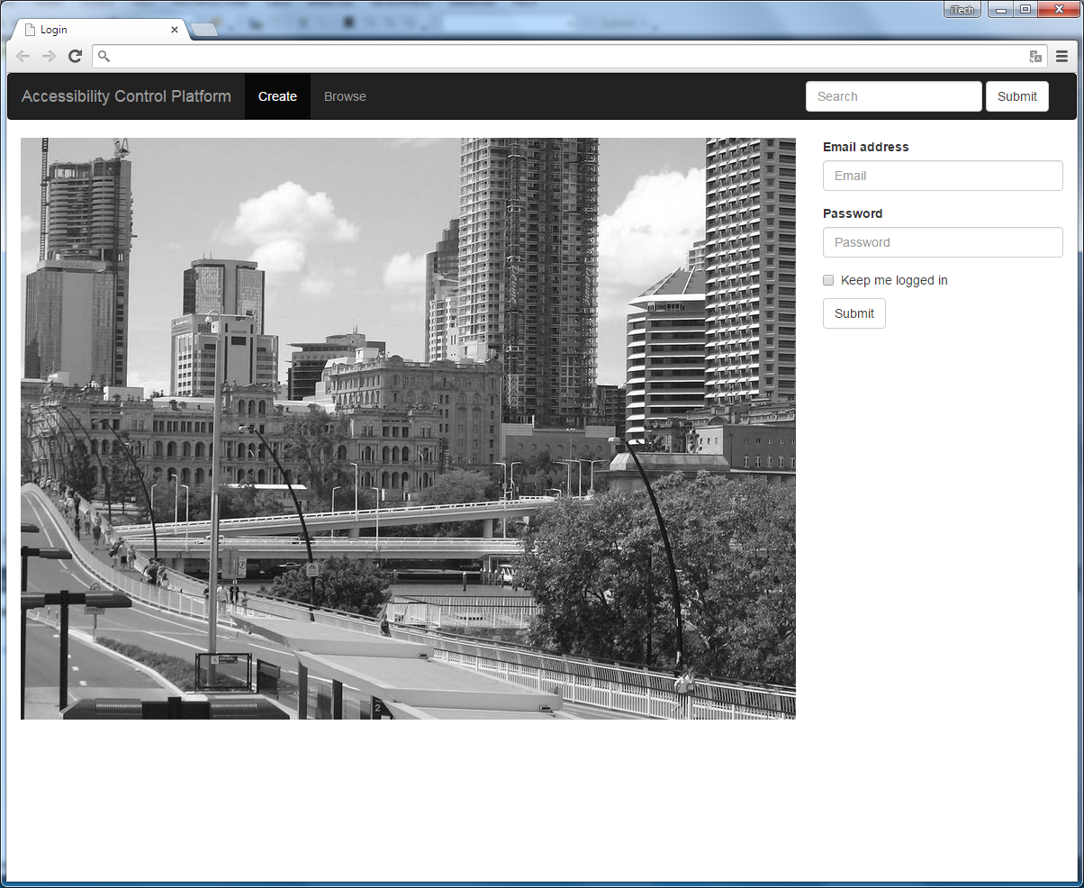

## Home Screen

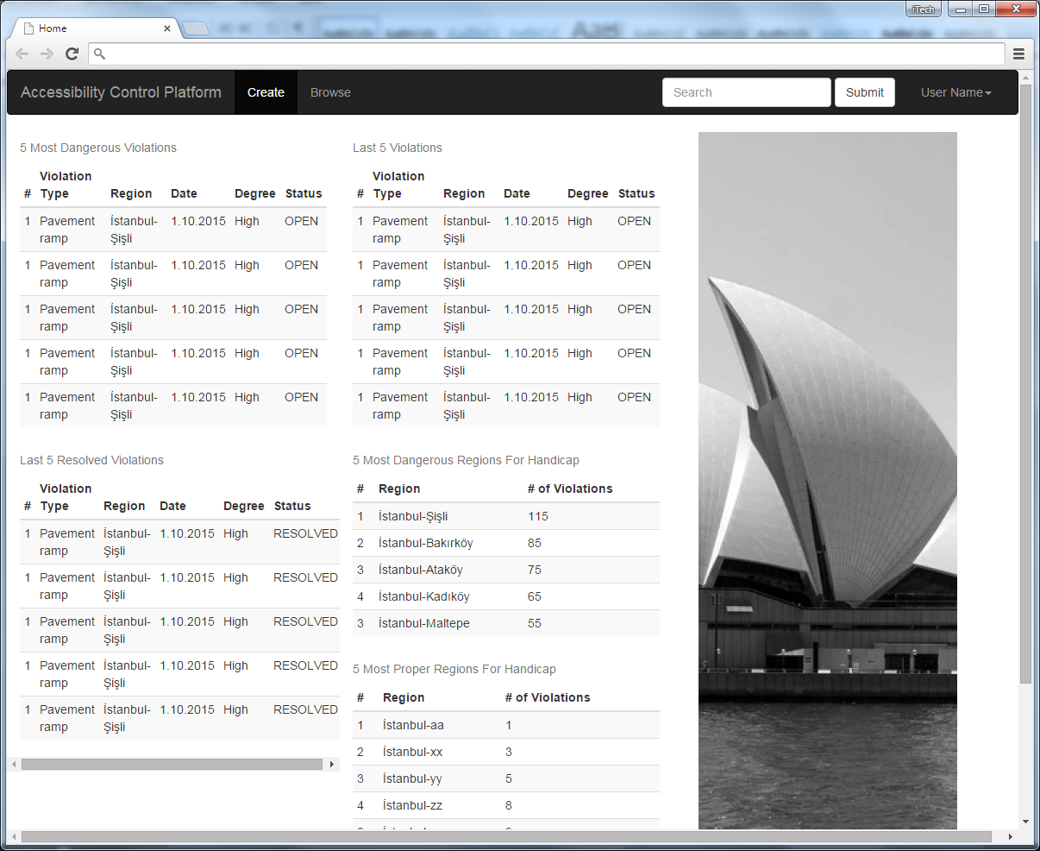

## Create New Violation

